Resort Credit Booking

- Locate the guest.
  - This can be found by referencing the reservation number provided to the guests via email
  - This can also be found in COVID-19 spreadsheet https://docs.google.com/spreadsheets/d/1yyVmLDkgpkGobJ1uvw7bZbe6ChJ-fillee2jJZK4Dk0/edit#gid=1752183772

- Book the new reservation
  - Search and book availability with dates inside of 365 days of original booking via Travel Click Call Center App.
  - Complete booking as normal
  - Notate in the travel click Guest Comment field that this is a Resort Credit booking using all caps: RESORT CREDIT
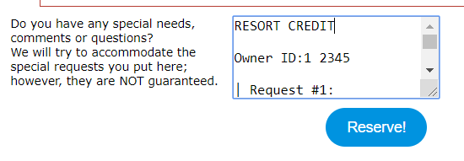

- Updated the resort credit tab on the COVID-19 Spread sheet with new booking information.
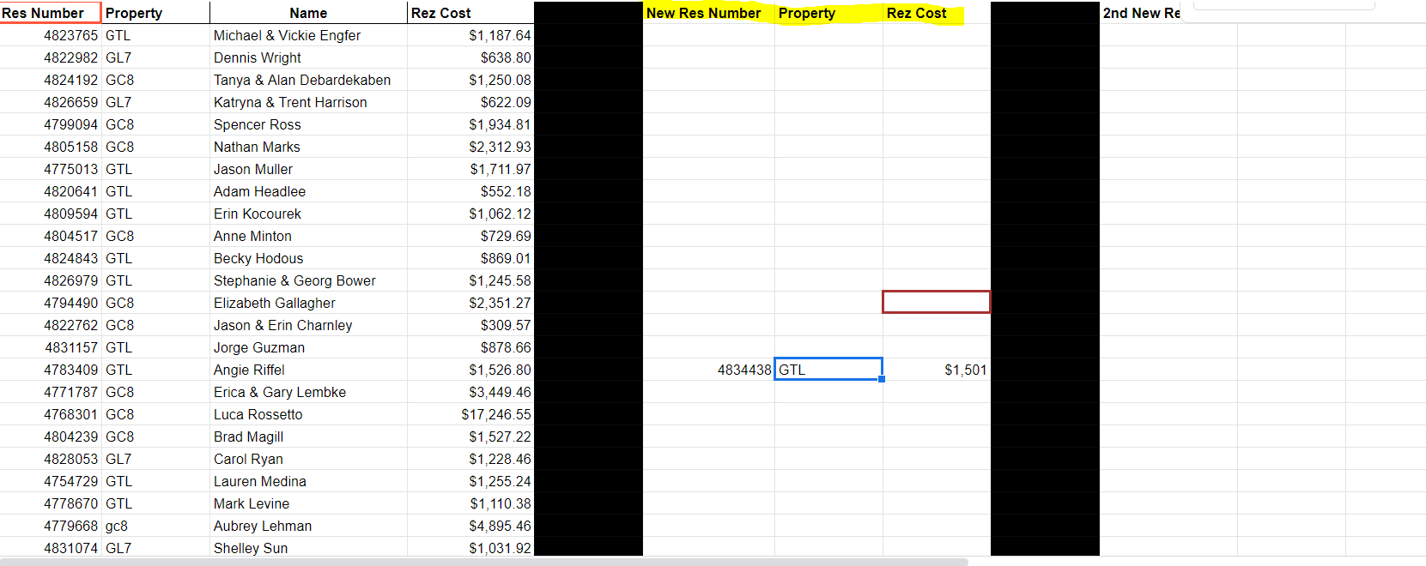

- Book reservation in tsw
  - Take any additional payment in tsw
  - Add normal notes
  - Add Resort Credit Res note
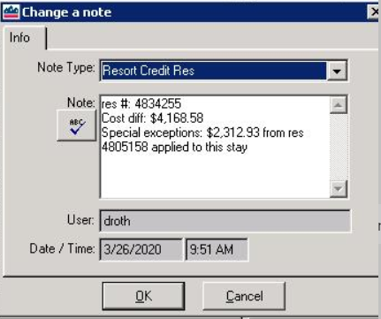

- VRD gets booking via Travel Click confirmation
  - Add on booking sheet
  - Add rates
  - Add resort credit amount to rate builder as a negative amount.